**Functional Document**

|  |  |
| --- | --- |
| **Applicaion** | NGERP – Centra |
| **Service Bundle** | Inventory Management |
| **Service Request** | Internal Transfer |

**Description:**

In **Compiere (NGERP - Centra)**, the system facilitates the movement of inventory between **locations** or **warehouses** using the **Internal Transfer** Window.

**Workflow Process:**

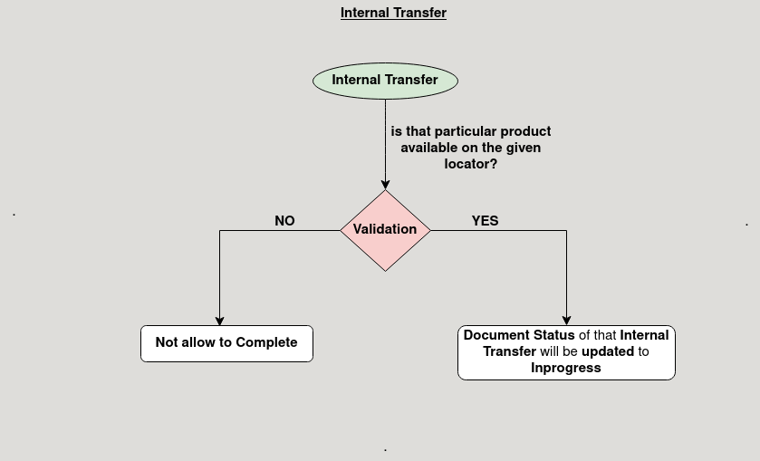

**Business Rules:**

* It is visible in both **HQ** and **ROW**.
* **Creation** is possinle only in **ROW**.
* In **HQ** will be showing **all region Data.**
* Internal Transfers must specify both a source and destination warehouse, ensuring inventory is accurately moved between locations.
* Inventory quantities in both the source and destination warehouses must be updated when the transfer is processed, reflecting accurate stock levels.